A2.4 Flexbox - Basic

# EXERCISE 1: Flexbox *Froggy*

Resolve the 24 Flexbox Exercises of <https://flexboxfroggy.com/> and insert the CSS lines you have written in this table:

|  |  |  |  |  |  |
| --- | --- | --- | --- | --- | --- |
| **1** | justify-content: flex-end; | **2** | justify-content: center; | **3** | justify-content: space-around |
| **4** | justify-content: space-between | **5** | align-items: flex-end | **6** | justify-content:center;  align-items:center; |
| **7** | justify-content: space-around;  align-items: flex-end | **8** | flex-direction: row-reverse | **9** | flex-direction: column |
| **10** | flex-direction: row-reverse;  justify-content: flex-end; | **11** | flex-direction: column;  justify-content: flex-end | **12** | **flex-direction: column-reverse;**  **justify-content: space-between;** |
| **13** | flex-direction: row-reverse;  align-items:flex-end;  justify-content:center; | **14** | order: 1 | **15** | **order: -1** |
| **16** | align-self: flex-end; | **17** | order: 2;  align-self: flex-end | **18** | flex-wrap: wrap |
| **19** | flex-wrap: wrap;  flex-direction: column; | **20** | flex-flow: wrap column | **21** | align-content: flex-start |
| **22** | align-content: flex-end | **23** | flex-direction:column-reverse;  align-content:center; | **24** | flex-direction: column-reverse;  flex-wrap:wrap-reverse;  justify-content:center;  align-content:space-between; |

# 

# EXERCISE 2. Reproduce these flexbox layouts.

Given the HTML in the file **index-ex1-to-4.html**, add the CSS that is needed to get the following displays.

You can’t modify the HTML! Only CSS!

### DISPLAY 1.

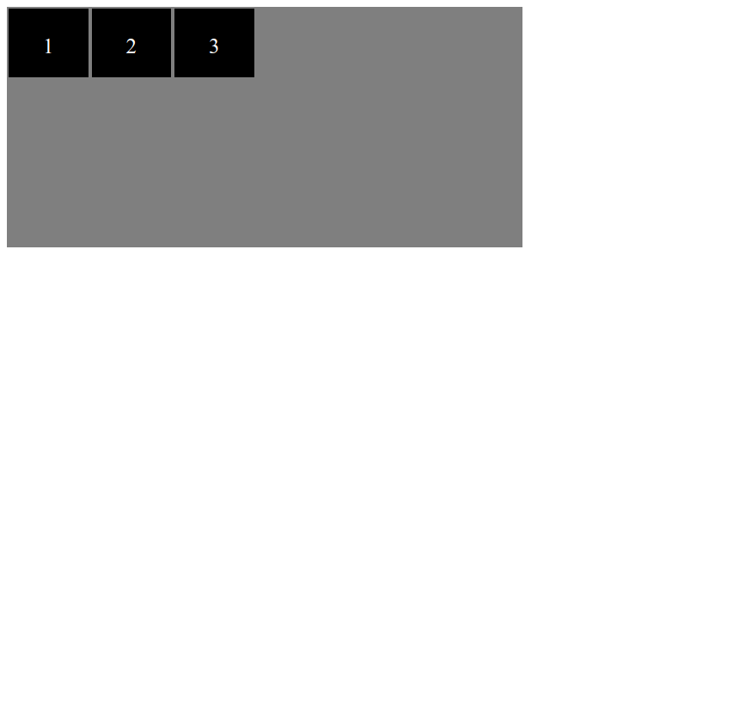

#### CODE:

|  |
| --- |
| .container{  display: flex;  } |

### DISPLAY 2.

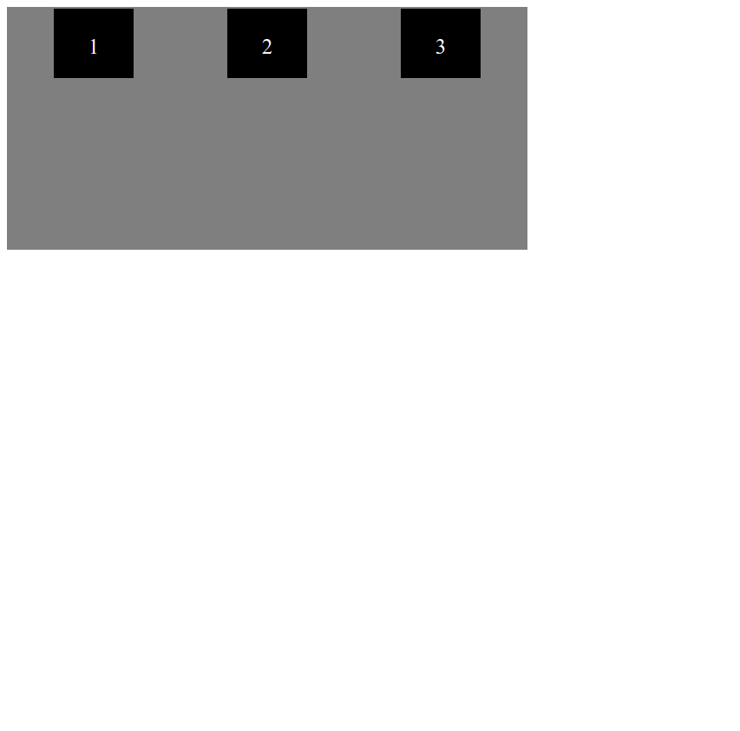

#### CODE:

|  |
| --- |
| .container{  display: flex;  justify-content: space-around;  } |

### 

### DISPLAY 3.

Give every item a width of 50px

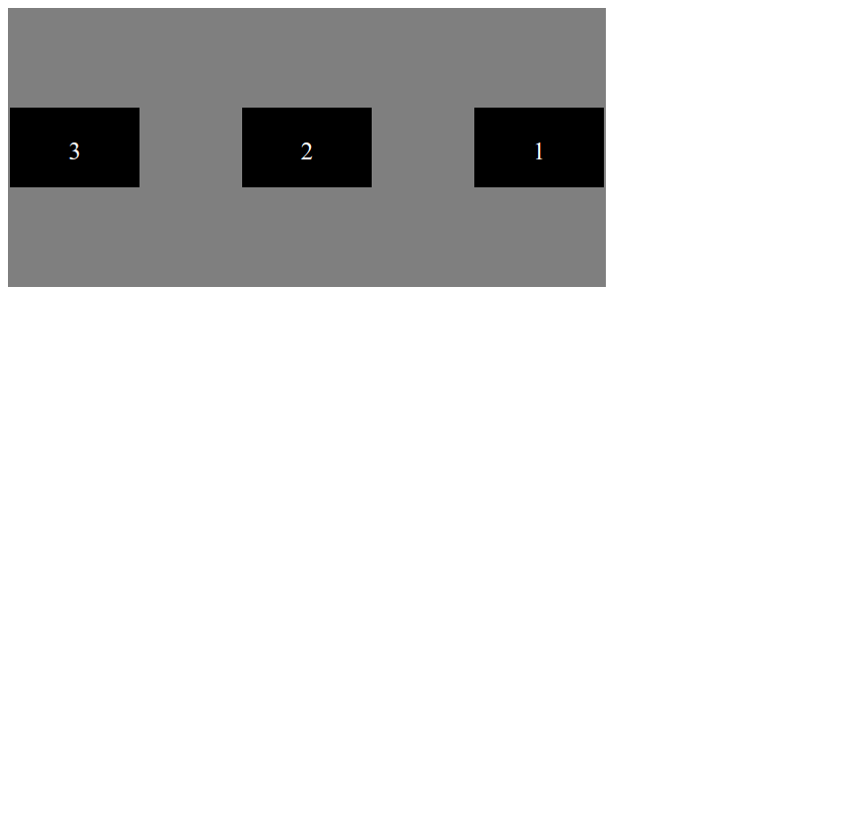

#### CODE:

|  |
| --- |
| .container{  display: flex;  justify-content: space-between;  align-items: center;  flex-direction: row-reverse;  }  .container div{  width: 50px;  } |

### DISPLAY 4.

Give every item a width of 50px



#### CODE:

|  |
| --- |
| .container{  display: flex;  justify-content: space-between;  align-items: center;  flex-direction: column-reverse;  }  .container div{  width: 50px;  } |

# EXERCISE 3. Reproduce these flexbox layouts.

Given the HTML in the file **index-ex5-to-7.html**, add the CSS that is needed to get the following displays.

You can’t modify the HTML! Only CSS!

### DISPLAY 5.

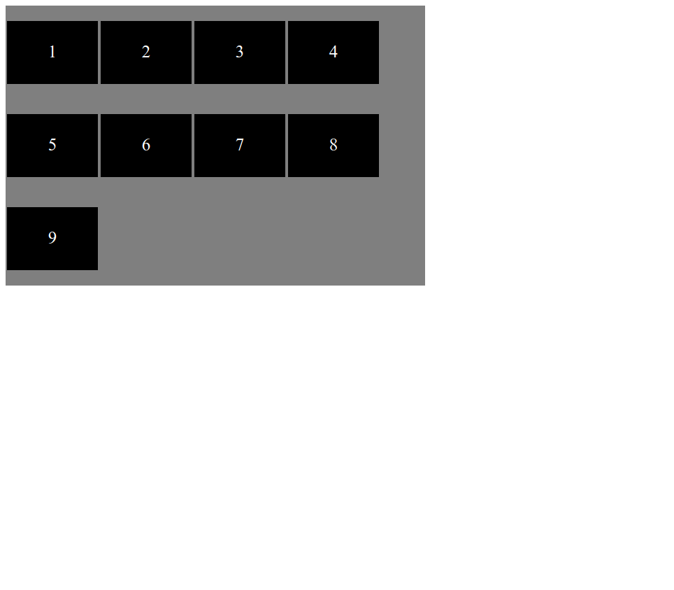

#### CODE:

|  |
| --- |
| .container{  display: flex;  flex-wrap: wrap;  } |

### DISPLAY 6.

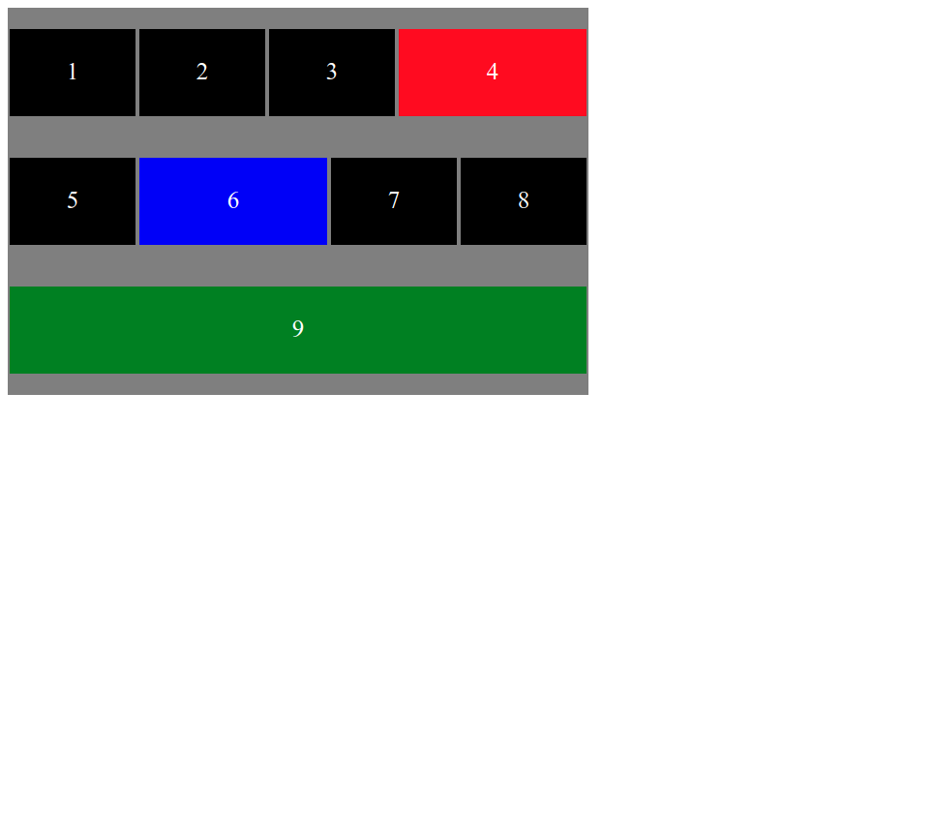

#### CODE:

|  |
| --- |
| .container{  display: flex;  flex-wrap: wrap;  }  #i4{background-color: red;flex-grow:1;}  #i6{background-color: blue;flex-grow:1;}  #i9{background-color: green;flex-grow:1;} |

### DISPLAY 7.

Canvia el contenidor a amplada 900px i alçada 150px.

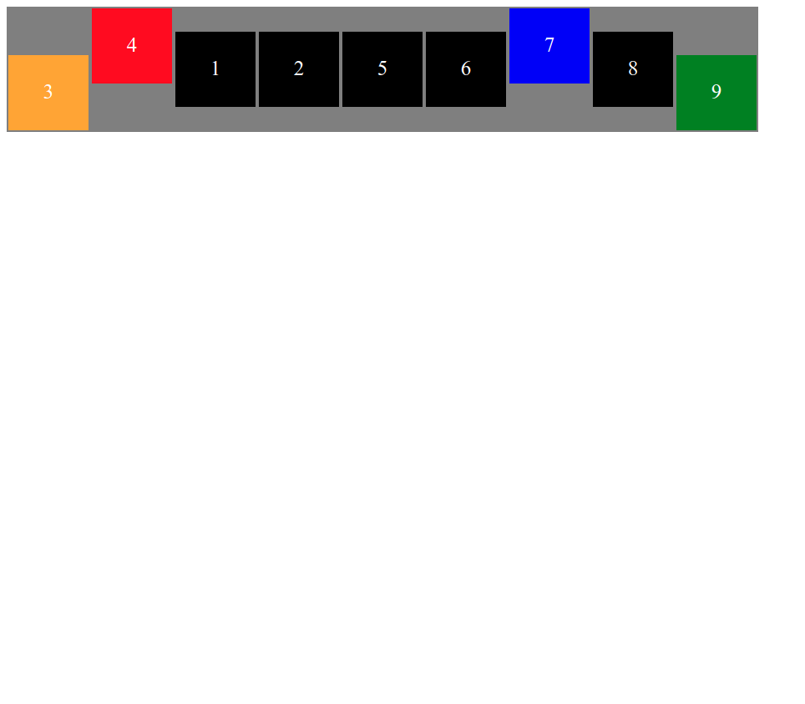

#### CODE:

|  |
| --- |
| .container{      display: flex;      align-items: center;  }  #i3{      order:-1;      background-color: orange;      align-self: flex-end;  }  #i4{      order:-1;      background-color: red;      align-self: flex-start;  }  #i7{      background-color: blue;      align-self: flex-start;}  #i9{      background-color: green;      align-self: flex-end;  } |

# 

# EXERCISE 4. Reproduce these flexbox layouts.

Given the HTML in the file **index-ex5-to-7.html**, add the CSS that is needed to get the following displays.

You can’t modify the HTML! Only CSS!

### DISPLAY 8.

Veure vídeo **video8.webm**

#### CODE:

|  |
| --- |
| .flex-container{  flex-wrap: nowrap;  }  .flex-container :nth-child(3){  background-color: red;  flex-shrink: 2;  }  .flex-container :nth-child(5){  background-color: blue;  flex-grow: 1;  } |

### DISPLAY 9.

Veure vídeo **video9.webm**

#### CODE:

|  |
| --- |
| .flex-container{  flex-grow: 0;  }  .flex-container :nth-child(2){  background-color: blue;  flex-grow: 2;  }  .flex-container :nth-child(6){  background-color: green;  flex-grow: 2;  }  .flex-container :nth-child(10){  background-color: red;  flex-grow: 2;  } |